Friday 5th June 2020

Reminder of arrangements for children returning to school on Monday 8th June 2020

Dear Parents
We are really looking forward to seeing your children on Monday and I wanted to send you a reminder of arrangements.

Arrival and Departure times for each group. Please ensure you stick to these times.
 | Entry |  | Exit
Days in School | Time | Year Group | Time | Year Group | Staff
Monday to Friday | 8.30 – 8.45 | Key Worker | 3.10 | Key Worker | Monday – BT & PS  Tuesday – BT & JW  W, Th & Fr – PS & JW
Monday, Tuesday & Wednesday | 8.50 – 9.05 | Reception | 2.30 | Reception | MB & NB
Monday, Tuesday, Wednesday & Thursday | 9.10 – 9.25 | Year 1 | 2.45 | Year 1 | EK & DK
Monday, Tuesday, Wednesday and Thursday. | 9.30 – 9.45 | Year 6 | 2.55 | Year 6 | SG & MS

Reception Class
Reception class (this reception group will be using the reception classroom) will need to line up on a flower (these are 2m apart), each child will be called 1 at a time, so they can wash their hands and put belongs away. Once the sink is free the next child will be invited in. This will take a little time at first but is a necessary step. At the end of the day we will ask parents to line up on the flowers, we will then dismiss the children one at a time to you. Maximum capacity in this room for children is 8

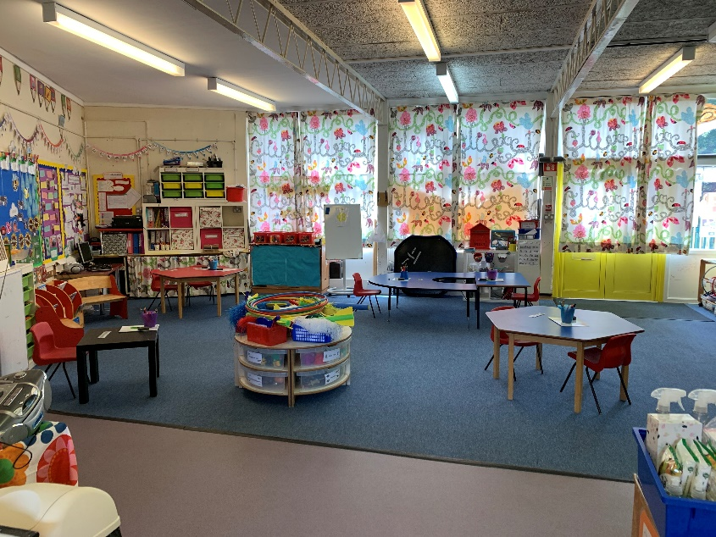

Year 1
Year 1 (this group will be using the year 1 classroom) will need to line up on the measured lines outside the year 1 classroom. Each child will be called 1 at a time, so they can wash their hands and put belongs away. Once the sink is free the next child will be invited in. This will take a little time at first but is a necessary step. At the end of the day we will ask parents to line up on the lines, we will then dismiss the children one at a time to you.
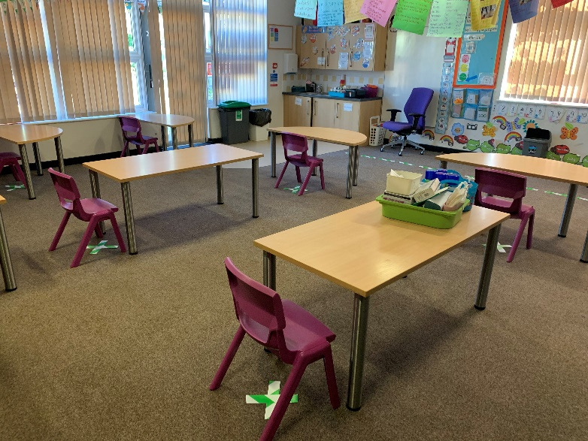

This is the year 1 room; each child will be assigned a table for the duration. They will have their own equipment and this will stay with them at all times. Each table is 2m apart.

Maximum capacity of children in this room is 8.

Year 6
Year 6 (this group will be using the year 6 classroom now) will need to line up on the spirals. Each child will be called 1 at a time, so they can wash their hands and put belongs away. Once the sink is free the next child will be invited in. This will take a little time at first but is a necessary step. At the end of the day we will ask parents to line up on the spirals, we will then dismiss the children one at a time to you.
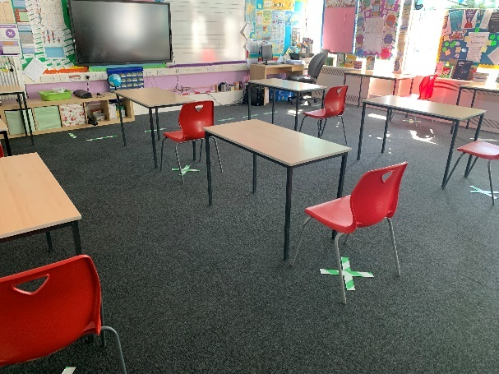

Year 6 will be using the Year 6 room; each child will be assigned a table for the duration. They will have their own equipment and this will stay with them at all times. Each table is 2m apart.

Maximum capacity of children in this room is 10.

Miss Dixon unfortunately is unable to be in school as she has a shielding letter. Mrs Hill is also unable to be in school.

Key Worker Group
This group will continue to be in the hall and will continue to enter through the main entrance door in reception. There is a queuing system in place. Children will wash hands before entering the hall.
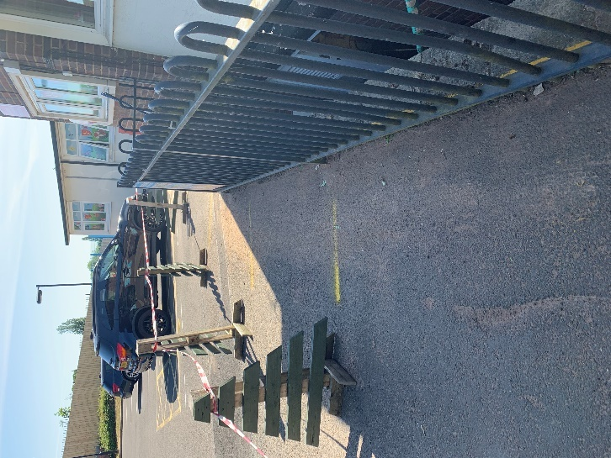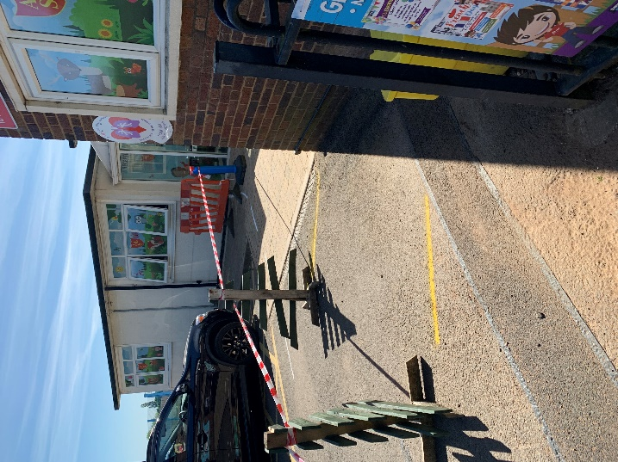

Dinner time and snacks
All children will need to bring with them a packed lunch until further notice. A healthy snack for playtime we have no fruit at the moment and their daily drinks. Children will be eating in the classrooms/ outside areas.

What should Children bring to school?
Jacket, lunch bag, drinks bottle, snack, any medication they need. They do not need to bring anything else into school.

What should they wear?
We understand that uniform now may be too small, so uniform is optional. However, we do ask that sensible footwear such as trainers are worn as some days might be active.

Other things you need to know;
- The pedestrian entrance will be closed
- Only 1 parent is allowed to drop off or collect their child, as per government direction.
- Parents are advised to either walk, cycle or drive to the setting – no travel by public transport
- The main gated entrance will be divided into two in order to operate a one-way system in and out of the school site. It will be clearly marked by lines painted onto the floor with paint and a physical barrier also running down the middle of the divide on the drive.
- Staggered drop off and pick up times (see table earlier in letter)
- A one-way system will then run around the perimeter of the school site. This will be clearly marked with signs and markings. (Down the drive, through the blue gate side of the staff room to the left down the steps, past year 1 classroom, down the passage side of new build, across the playground, through early years and then back the carpark to go up the left-hand side of the drive).
- We will be encouraging parents to contact the office by phone or email. Where this cannot happen and they need to come to the office there will be a queuing system in place with clearly marked 2m spacing between each person. Only one adult in the conservatory area at a time and they will have to stand behind the taped line.
- Hand sanitiser will be available in the conservatory area, visitors will be asked to use it before they touch the signing in machine, or use the table etc…
- No parent will be permitted into the building. (not even to use the toilet)
- Staff will patrol at key times of the day to ensure that parents are following one-way system, not congregating and breaking 2m distancing rules.

Playgrounds
- Climbing apparatus is taped off as it is not to be used
- Children will use the same area with their group only – they will not cross into another area and mix with others in a different group
- No physical games will be allowed that may involve physical contact (football, basketball, tag etc…)
- Children can sit in groups but must be 2m apart (benches are marked with an x showing where they can sit.
- Each group will have their own playtime/ outside box that is only used by that group (for example - skipping ropes, paper, pens, chalks, bean bags, books, games etc…)

Please also be conscience that we may have to close classes, school with no or very little notice if we were to have a confirmed case in school or due to staff illness. Please also be aware that as things change over the coming week the amount of time spent in school may also change. If numbers go up we may have to reduce days in order to be able to accommodate this with the number of staff available to work. Therefore, I would like to remind you that we need notice if you require your child to come back to school.

Schools will make every effort to keep children in a safe environment, following Government guidance; however, I need to be clear that schools cannot guarantee there will be no transmission of the COVID-19 virus.

See you on Monday
Best Wishes
Mrs N Crozier

